Context
This assignment is designed to introduce you to some of the functionality in Neara, and test your ability to use it to answer a customer question.
In this assignment, we will be seeing how much value there is in switching from an 'age based' to a 'value based' replacement strategy for our customer. They replace 28 out of every 1000 poles in their network each year, and they have a full network of 100,000 poles. You are running a pilot on a small but representative section of the network.
See some videos to assist with completing Task 1 and Task 2 here

Task 1. Calculate value of replacement for each pole
Objective: Calculate the value of replacing (or intervening) for every pole in the Asset List data table.
First steps:
- Open this project link (https://app.neara.com/?org=interview#designId:dh4rPWnykpX1) and create a copy with the button on the top yellow ribbon.

- You should see the following screen
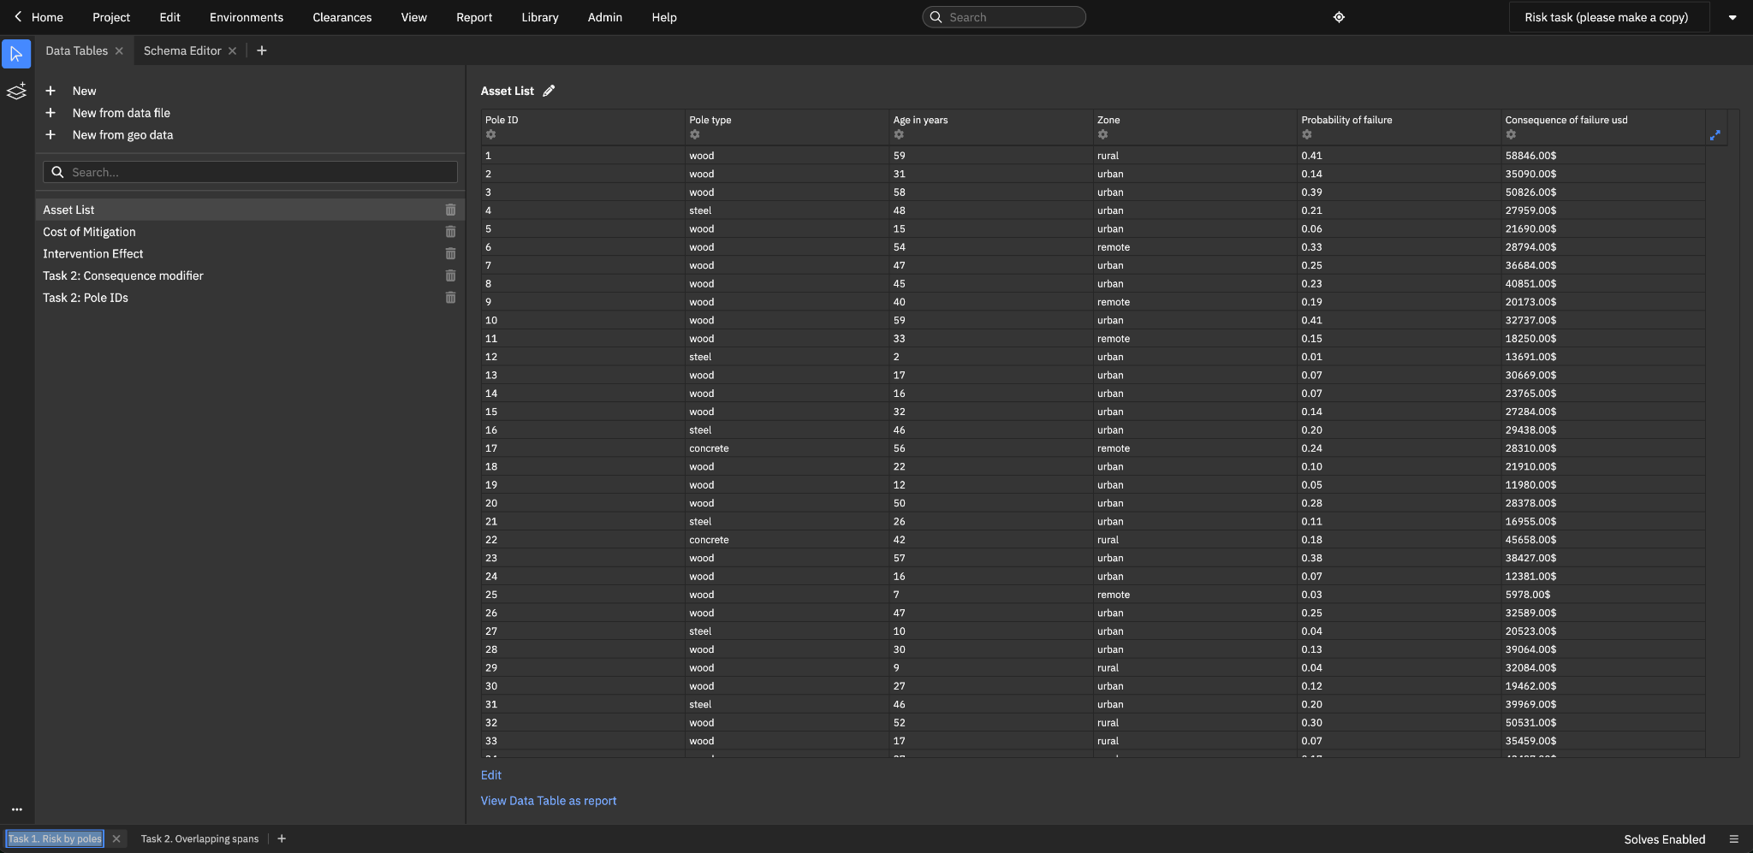
- Please adjust the sharing properties of your project by navigating to Project > Share and change to the Access Level under Users and teams to None.
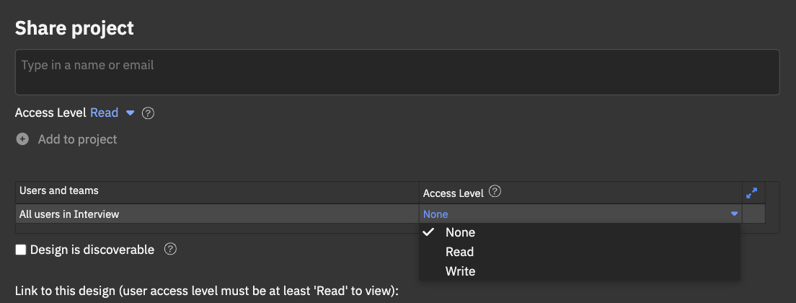

Watch the video with more guidance on how to use Neara to complete this task
Written documentation of useful functions:
- find
- filter
- broadcast
- boolean operations
- mathematical operations

Task 2. Find risk of overlapping spans
Objective: Find how many spans are overlapping, and apply the correct risk modifiers back to the original risk calculations in the Asset List table.
First steps:
- In the same project, click on the second tab at the bottom to see a handful of spans that have additional information modelled
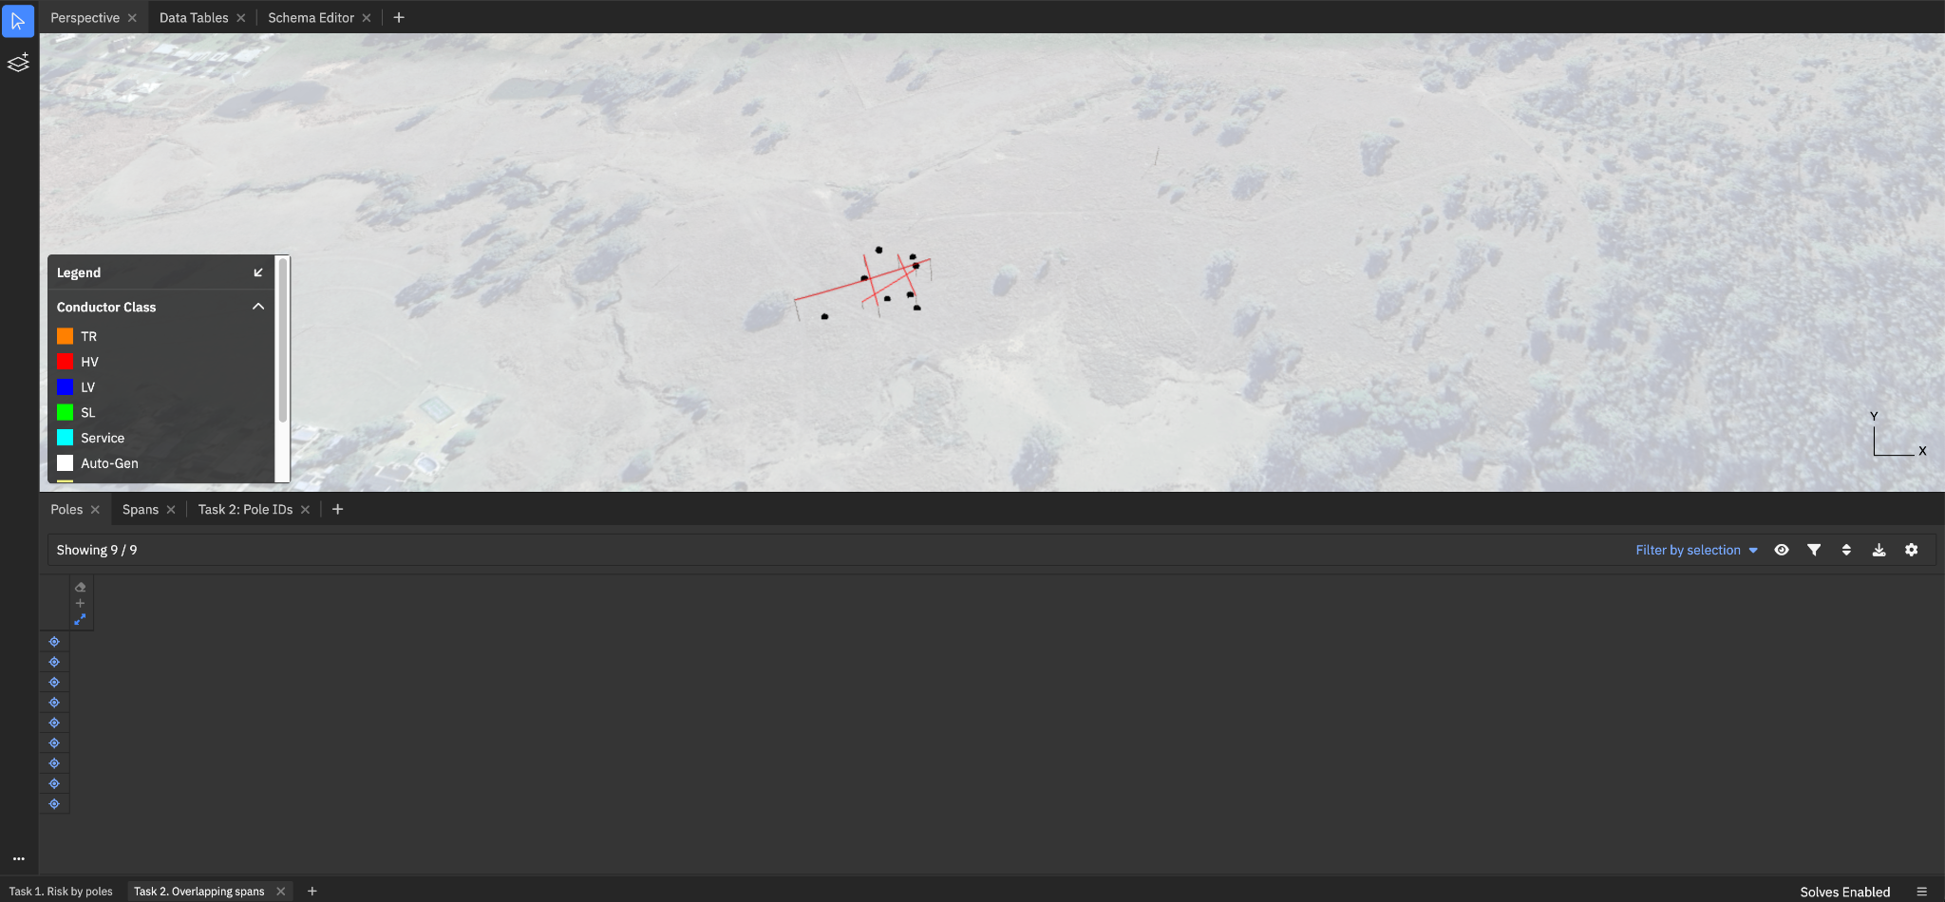
- Watch the task 2 video for more guidance on how to use Neara to complete this task

Other useful context
- Each ‘dot’ corresponds to a pole. You will need to somehow determine which dot corresponds to which pole and combine the data, so you can find the pole ID (in Pole IDs) of each pole (in Poles). The geo_query function will be useful for this task.
- You will use this pole ID to update the span overlapping risk back onto the main data table (Asset List)
- Overlapping here can be seen as how many spans are ‘below’ the span, and ignore the ones above
- model().Spans can help access the spans table, in the same way that model().dt_asset_list would access the manual data tables.
- Lots of normal maths/excel functions are in Neara, and behave as you would expect (e.g. len())
- If for some reason the dots disappear or the pole ID table is empty, press ‘F’ and click on the map where the poles are. You can click the crosshair next to a pole in the Poles table to auto zoom to it if you lose it on the map

Written documentation of useful functions:
- geo_query
- The set of find_ functions

Task 3. Calculate the benefits, and summarise in a short report
Objective: Calculate and communicate the results and recommendations of the project (in particular customer ROI) in a short report to be presented to the customer
First steps:
- Download your table as a csv

- Summarise/pivot your results as you wish
- Summarise your findings in a report, either a word doc or slides

Please share your Neara project URL with us in the presentation, and in the comments attached to your submission

Please do not use AI to complete the homework. You’ll be further tested on these functions and logic in a live interview, so it will be important that you somewhat understand them, and we are interested in how you articulate your ideas.

